**Comprehensive performance evaluation of water and power production technologies using water-exergy nexus analysis**

***An online supplementary file***

Pouya Ifaei1,+, Amir Saman Tayerani Charmchi1,+, Mattheos Santamouris2, ChangKyoo Yoo1,*

*1Integrated Engineering, Dept. of Environmental Science and Engineering, College of Engineering, Kyung Hee University, 1732 Deogyeong-daero, Giheung-gu, Yongin-si, Gyeonggi-do, 17104, Republic of Korea*

*2 School of Built Environment, University of New South Wales, Sydney, New South Wales, Australia*

*\* Corresponding author. Tel: +82-31-201-3824; fax: +82-31-202-8854; email:* [*ckyoo@khu.ac.kr*](mailto:ckyoo@khu.ac.kr)

*+The first and second authors equally contributed to this research article.*

**Systematic literature review**

A Boolean search logic-based program was used to systematically review the WEN literature using the SCOPUS database, highlight the research gaps and the necessity of this study. The program ran employing two different variants sensitive to all forms of “water”, “energy”, and “nexus” keywords with a maximum six-words distance between the first two words and a compulsory inclusion of the third keyword. The first variant included all perturbations of the keywords in the survey to investigate the nexus between water, energy, and any other parties, whereas probable third parties (food, carbon, land, waste, and GHG) were eliminated in the second run. The targets of the survey were titles, abstracts, and keywords of publications in journals, books, and conferences since 2002 for the three search keywords. According to the systematic review, over 3,912 articles, reports, and book chapters about WEN have been published in English since 2002, which are presented in the **Supplementary materials**.

**S1 Conversion units**

The following unit conversion factors (UCF) were used for the calculations:

1 m3 water = 1,000 kg water = 1,000 L water = 264.2 gallons water

1 acre-foot water = 325,851 gallons

1 MWh = 3.6 GJ = 3.412 MMBtu

1 tonne = 1.102 ton

1 MJ = 0.277778 kWh

2.81 kg U3O8🡪kg UF6.natural

10.4 kg UF6.natural🡪kg UF6.enriched (Nuclear fuel enrichment by diffusion)

10.8 kg UF6.natural🡪kg UF6.enriched (Nuclear fuel enrichment by centrifugal)

3.42 kg UF6.enriched 🡪kg UO2

0.004 33 kg UO2 MWh-1

**S2 Detailed water-exergy nexus plots**

The following plots are illustrated to detail the WExN models based on the second to the sixth labels of the variables.

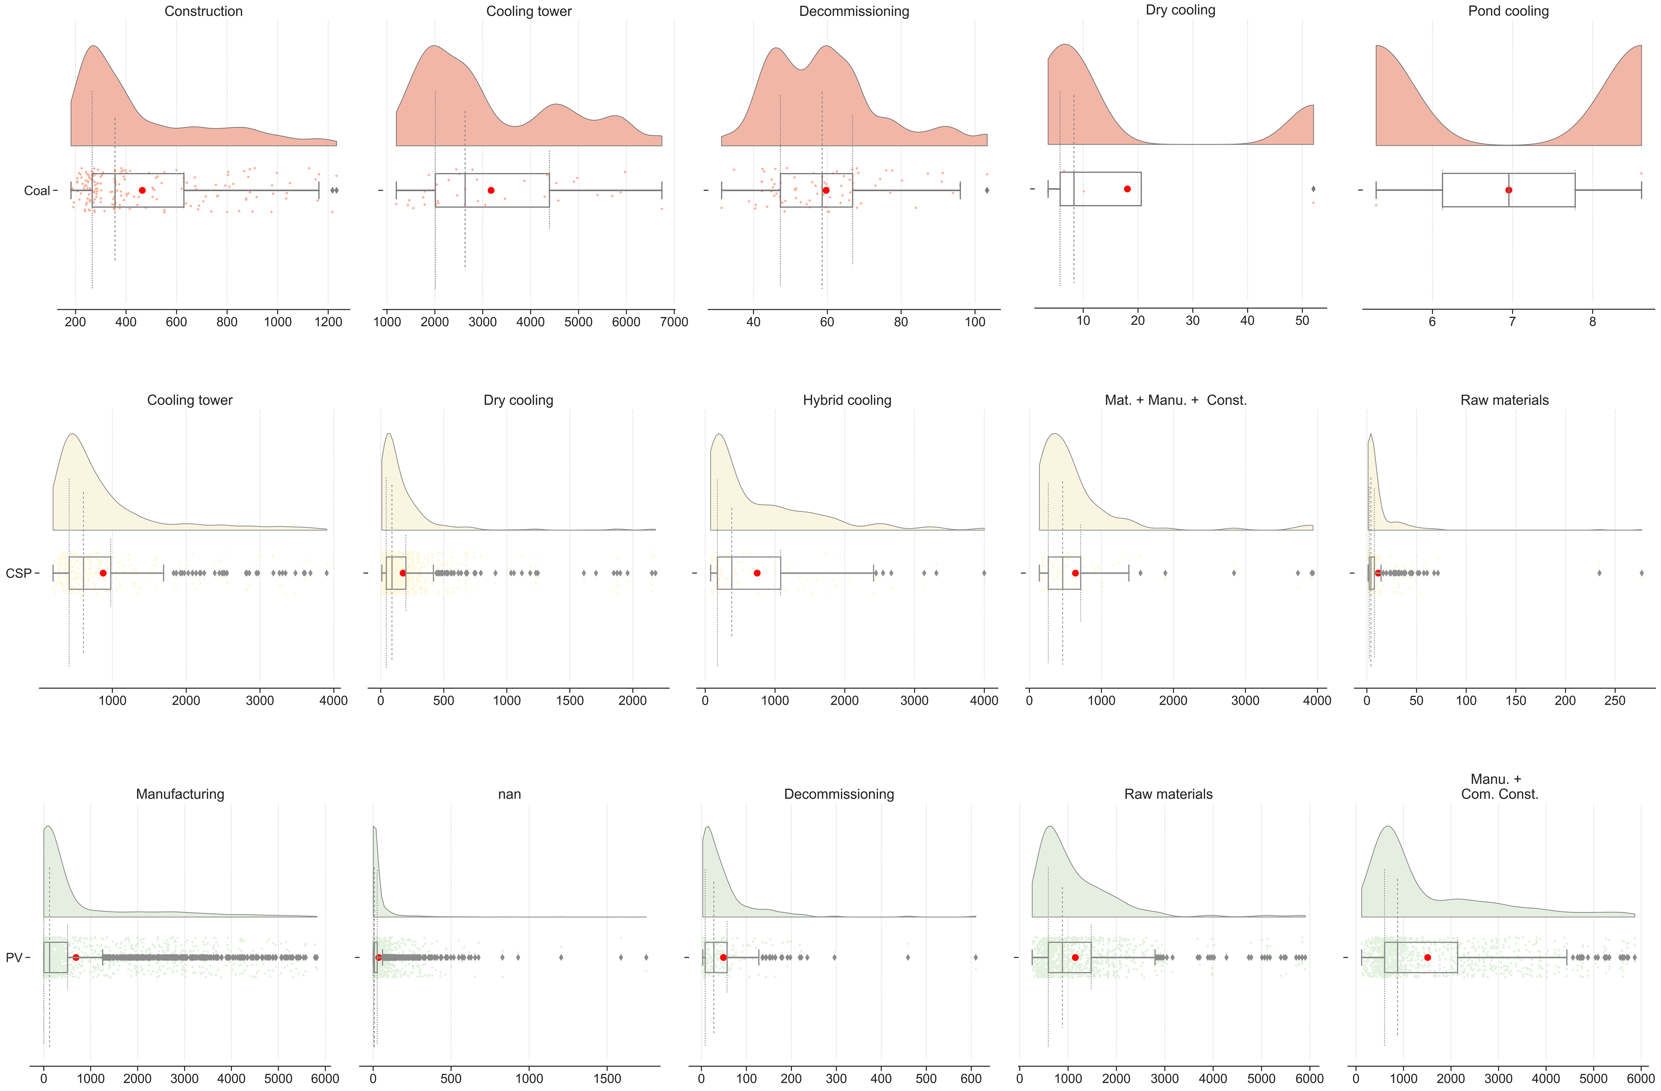

**Figure S1** Water withdrawal for exergy of coal, CSP, and PV power generation technologies considering the uncertainties under Label 5

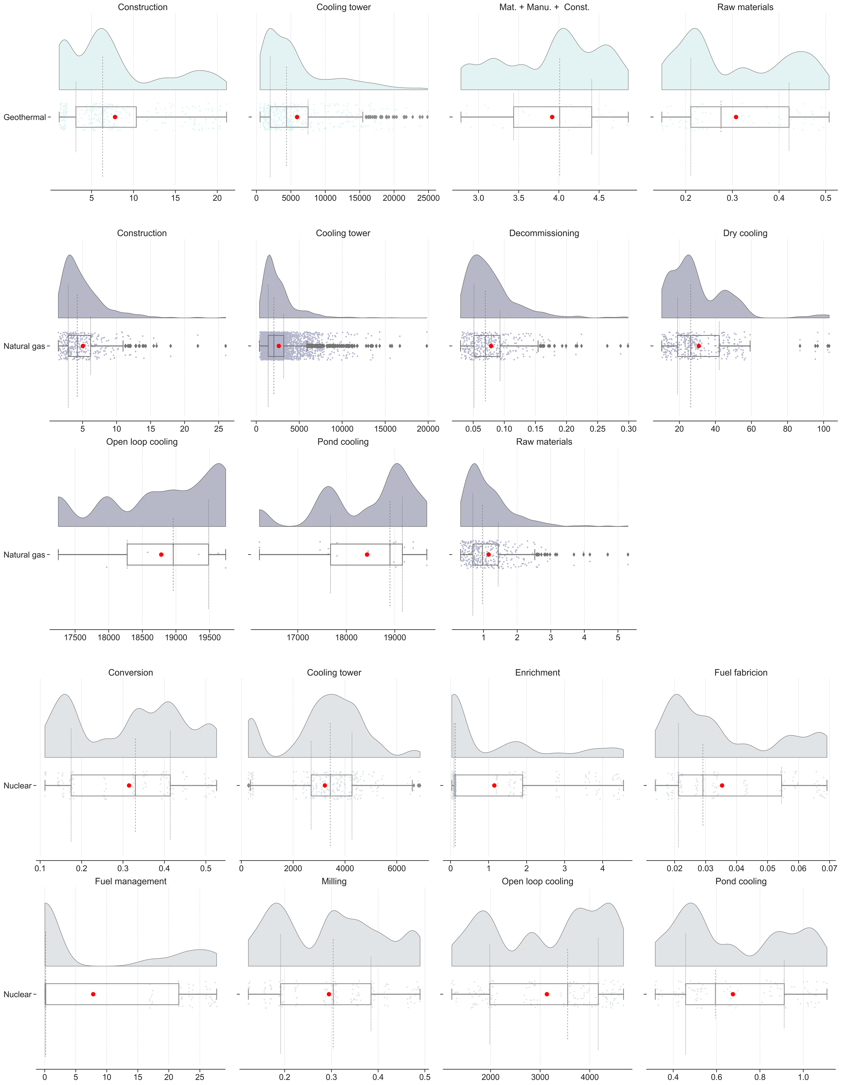

**Figure S2** Water withdrawal for exergy of geothermal, natural gas, and nuclear power generation technologies considering the uncertainties under Label 5

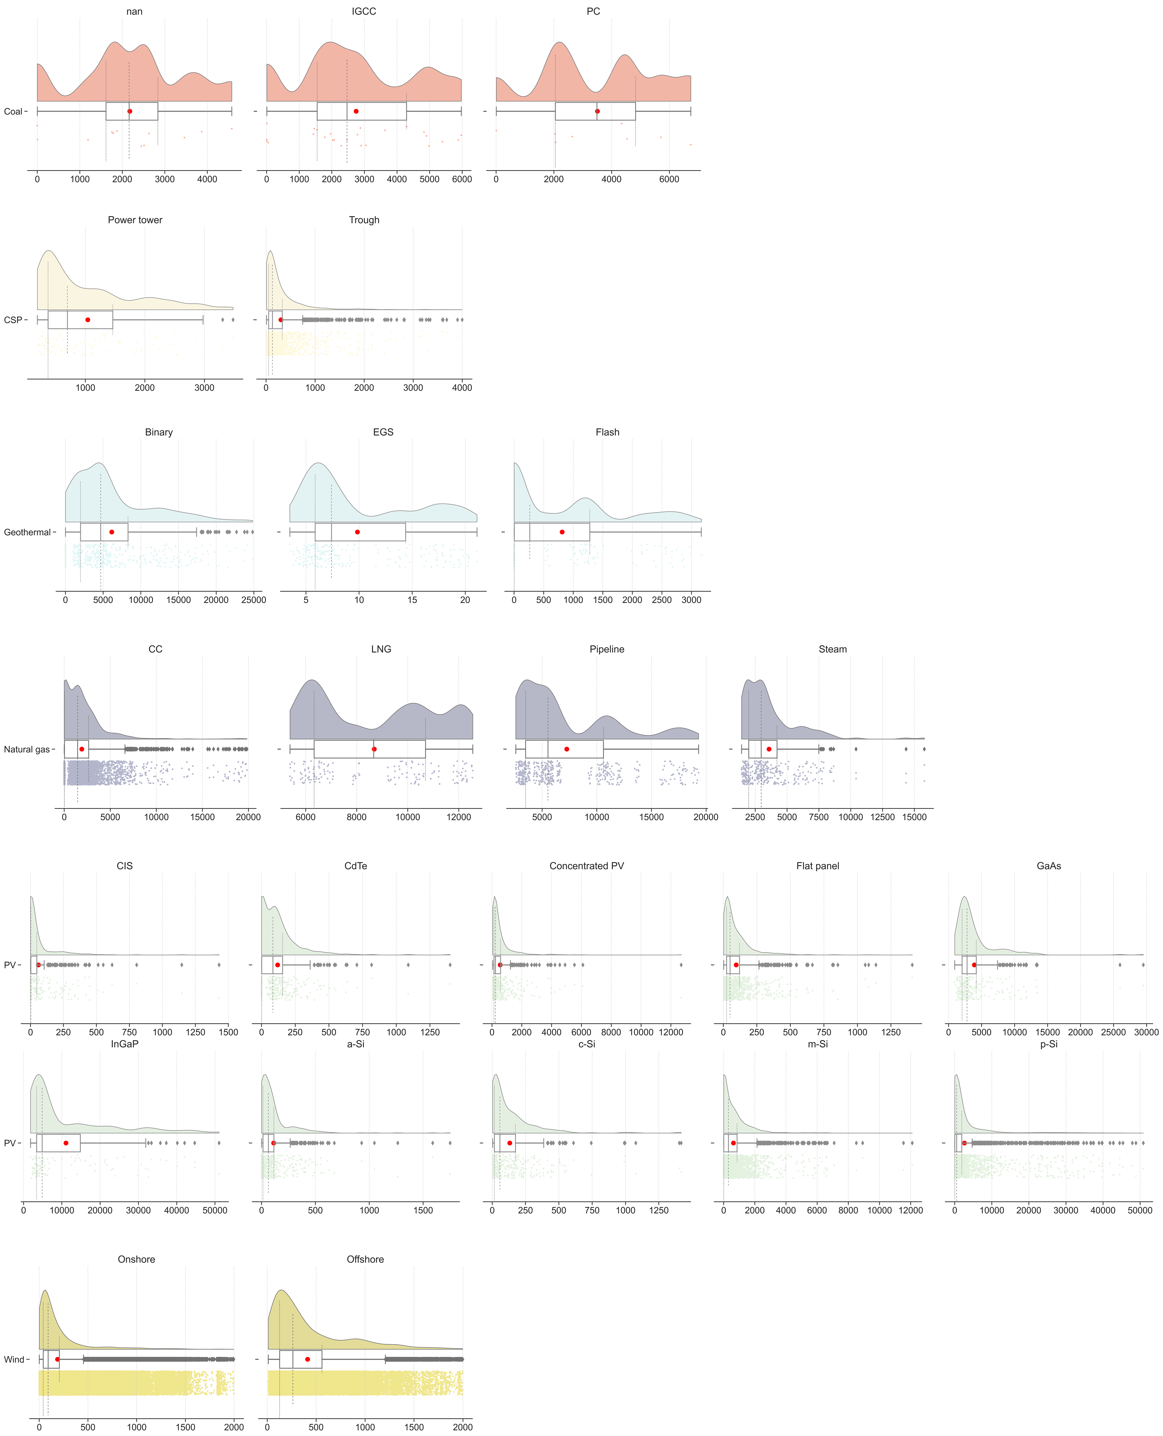

**Figure S3** Water withdrawal for exergy of power generation technologies considering the uncertainties under Label 6

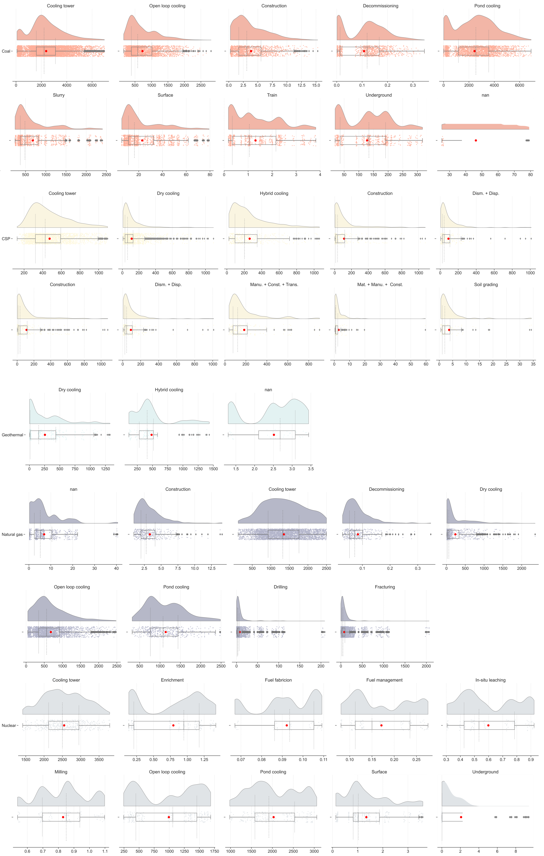

**Figure S4** Water consumption for exergy of power generation technologies considering the uncertainties under Label 5

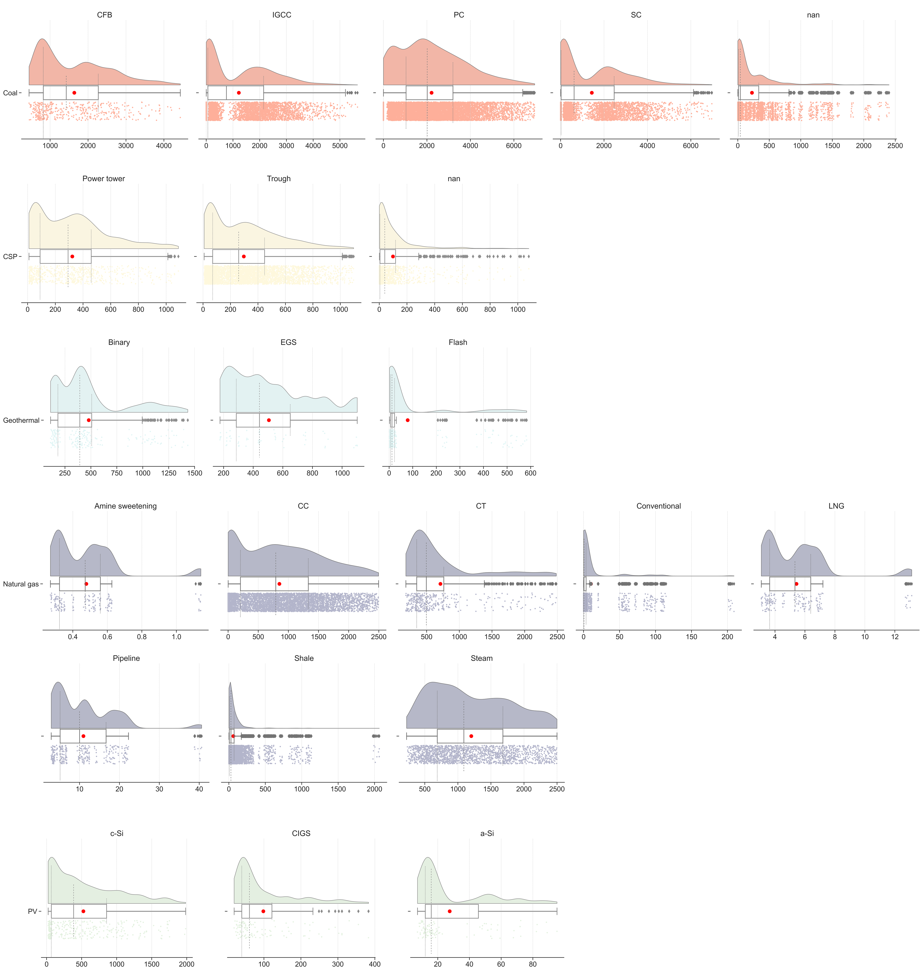

**Figure S5** Water consumption for exergy of power generation technologies considering the uncertainties under Label 6

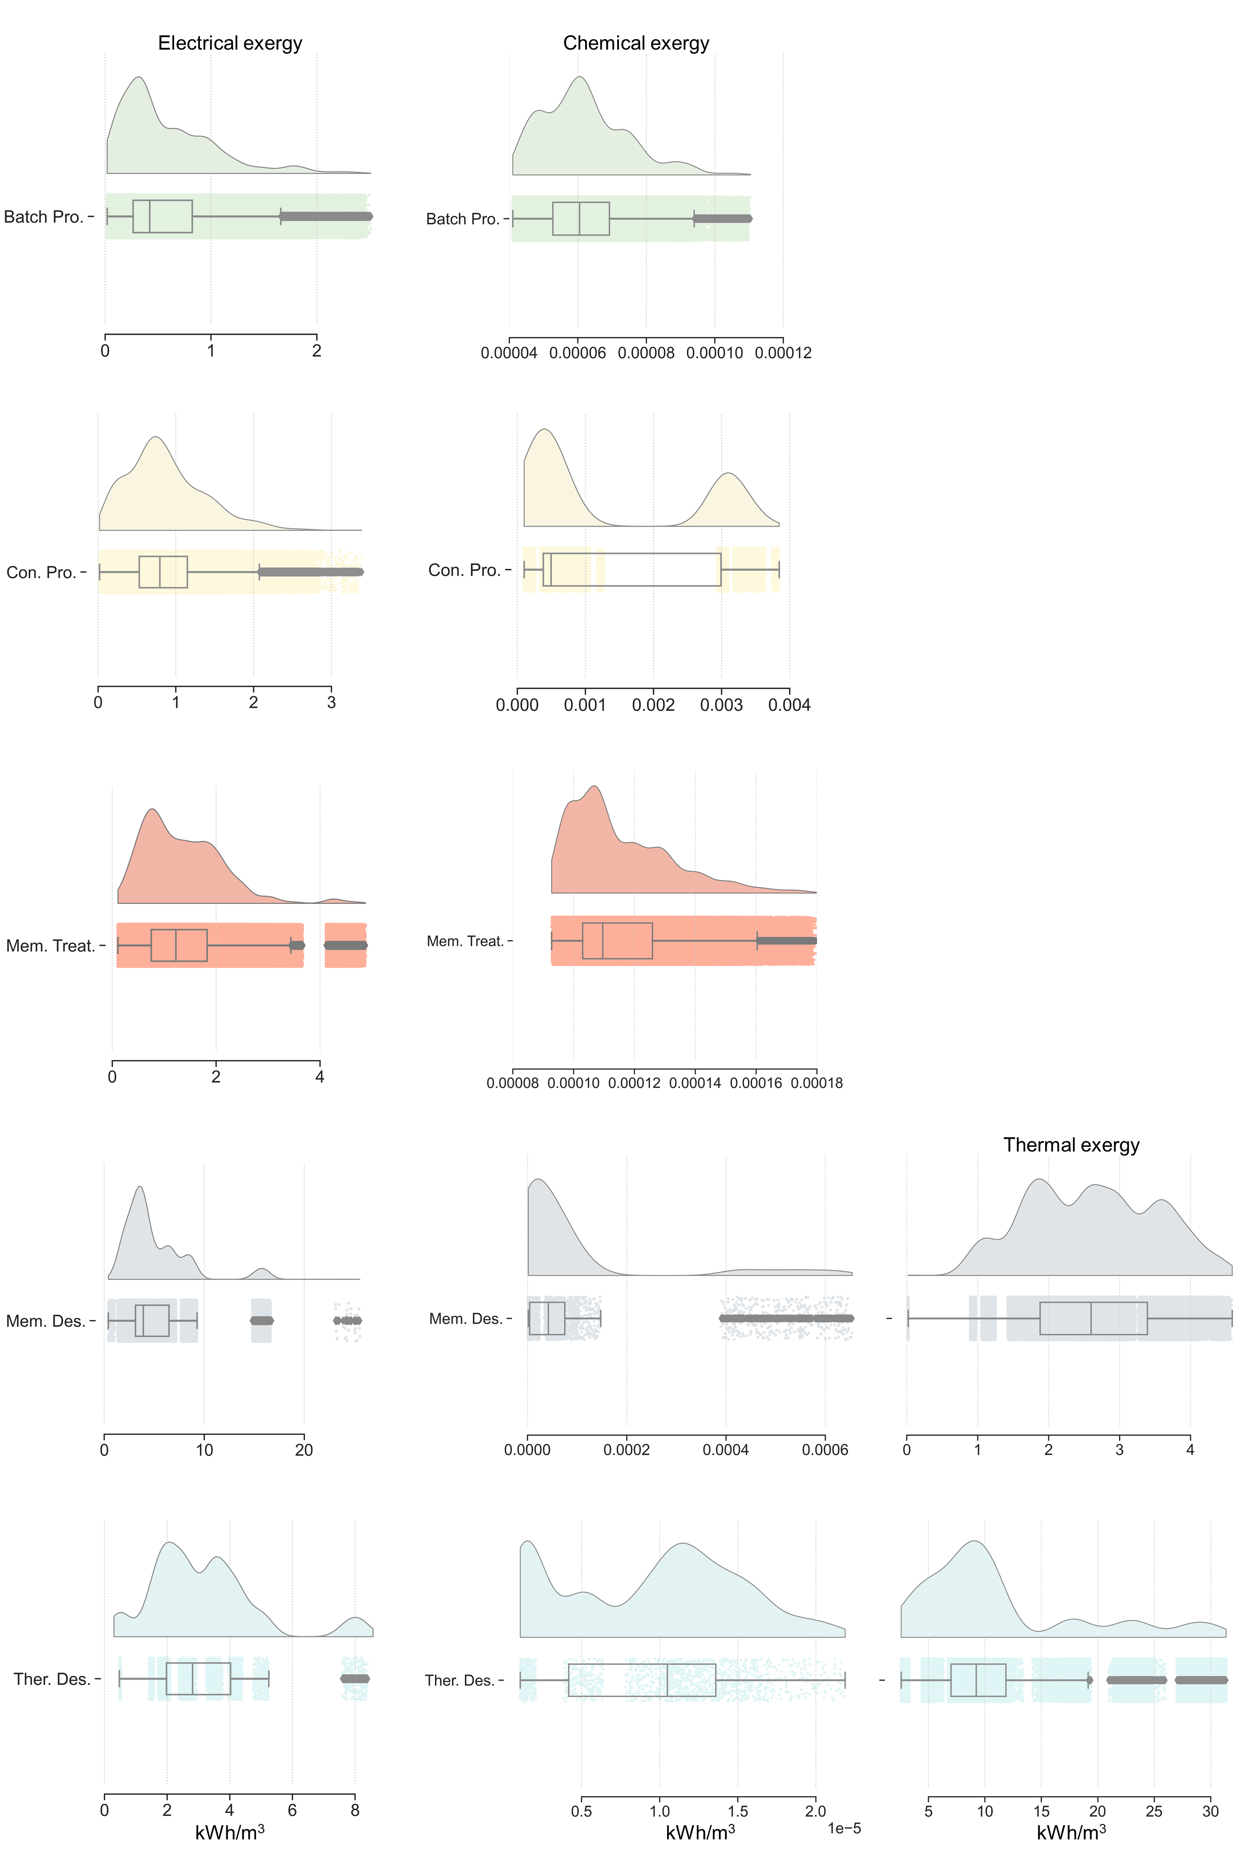

**Figure S6** Exergy dissipation for water production technologies considering the uncertainties under Label 4